M4.2 Assignment
Course: CSD310 – 340A
Prepared By: Mirach Erkol
Date of Report: 11/16/2025

https://github.com/Mikey5007/csd-310.git

M4.2 Assignment: MySQL Connection
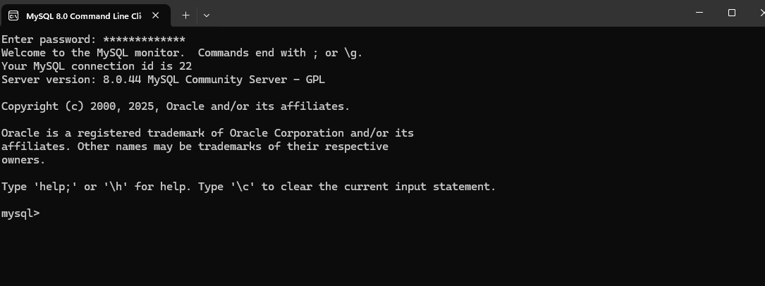

M4.2 Assignment: MySQL Database Creation
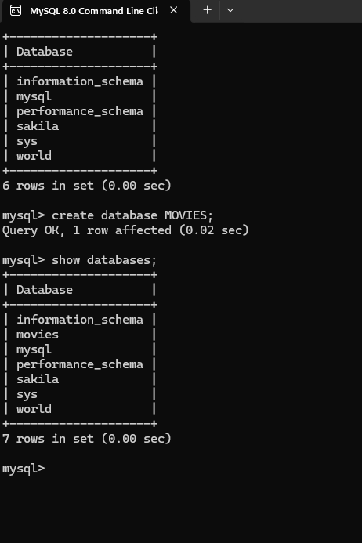

Mikey5007/csd-310: CSD

